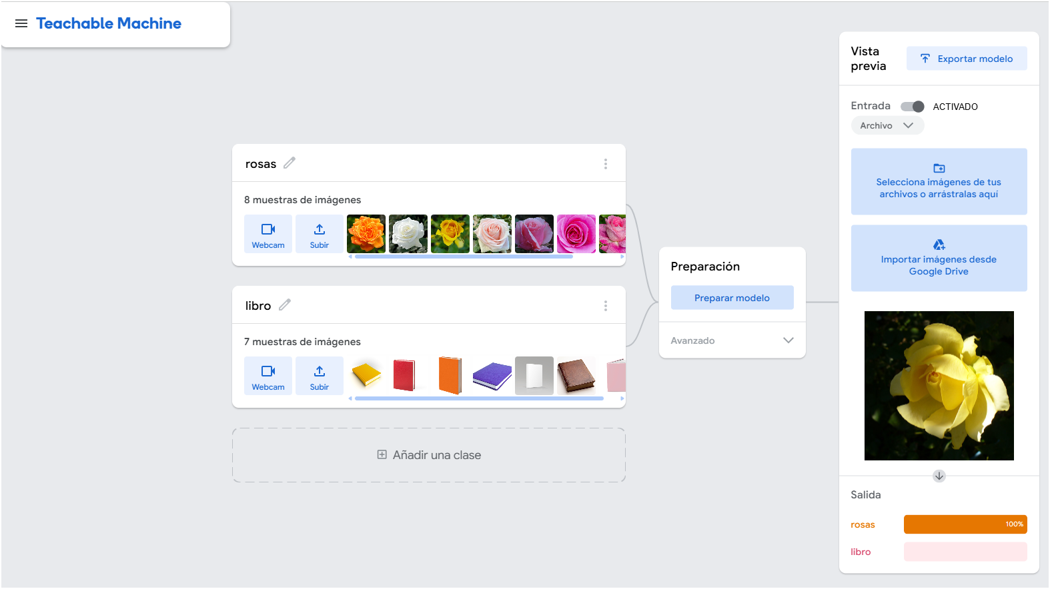
Practical Activity: Train Your Own Artificial Intelligence

Use Google Teachable Machine https://teachablemachine.withgoogle.com to create a model capable of recognizing objects through a camera.
- Select three different objects.
- Train the model using images of each object.
- Check whether the model recognizes them correctly.
- Test the model with different backgrounds and lighting conditions.
- Explain why recognition errors occur.

Save evidence of each step of the process.

Name the assignment file as:
YourSurname_YourName_Task_1.pdf

